**FUNDAMENTALS OF REINFORCEMENT LEARNING**

**Nguyễn Hoàng Việt – QE170216**

**AI17C**

**REL301m**

1. **Certificate**

Link: <https://coursera.org/share/cac46a48c77d447db587290d8c963b88>

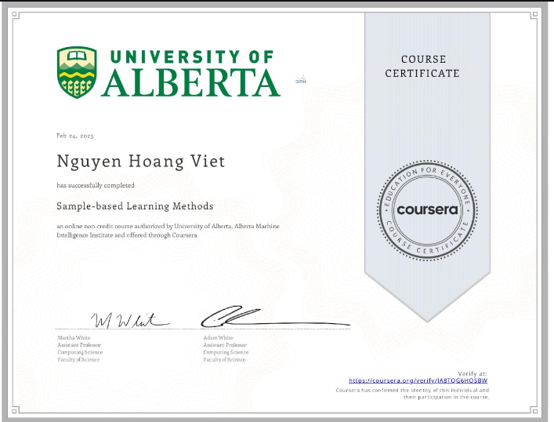

1. **Assignment**

* **TD with State Aggregation**: [link github](https://github.com/nguyen-hoang-viet/reinforcement-learning-course/blob/main/assignment/course%203/Semi-gradient_TD(0)_with_State_Aggregation.ipynb)
* **Semi-gradient TD with Neural Network:** [link github](https://github.com/nguyen-hoang-viet/reinforcement-learning-course/blob/main/assignment/course%203/Semi-gradient_TD_with_a_Neural%20Network.ipynb)
* **Function Approximation and Control:** [link github](https://github.com/nguyen-hoang-viet/reinforcement-learning-course/blob/main/assignment/course%203/Function_Approximation_and_Control.ipynb)
* **Average Reward Softmax Actor-Critic:** [link github](https://github.com/nguyen-hoang-viet/reinforcement-learning-course/blob/main/assignment/course%203/Average_Reward_Softmax_Actor-Critic_using_Tile-coding.ipynb)

1. **Quiz**

* On-policy Prediction with Approximation

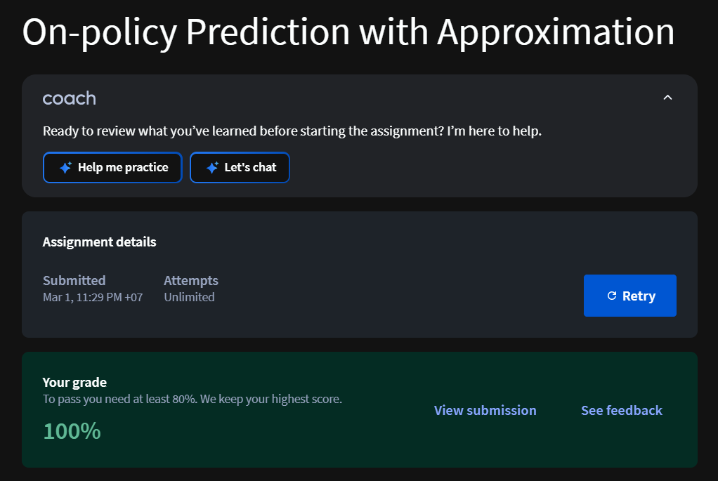

* Constructing Features for Prediction



* Control with Approximation

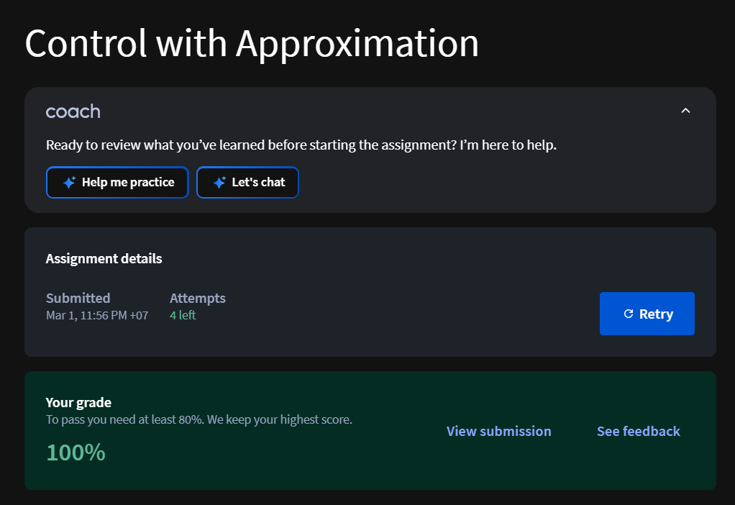

* Policy Gradient Methods

